**Create a file in Linux**

1. Empty file

$touch file1

$> file1

1. Make a text file

$cat > file1.txt

Add data and press ctrl+D(^D) to save file1.txt when using cat.

1. $echo ‘Sample text’ > file1

$cat file1.txt (to see content inside file)

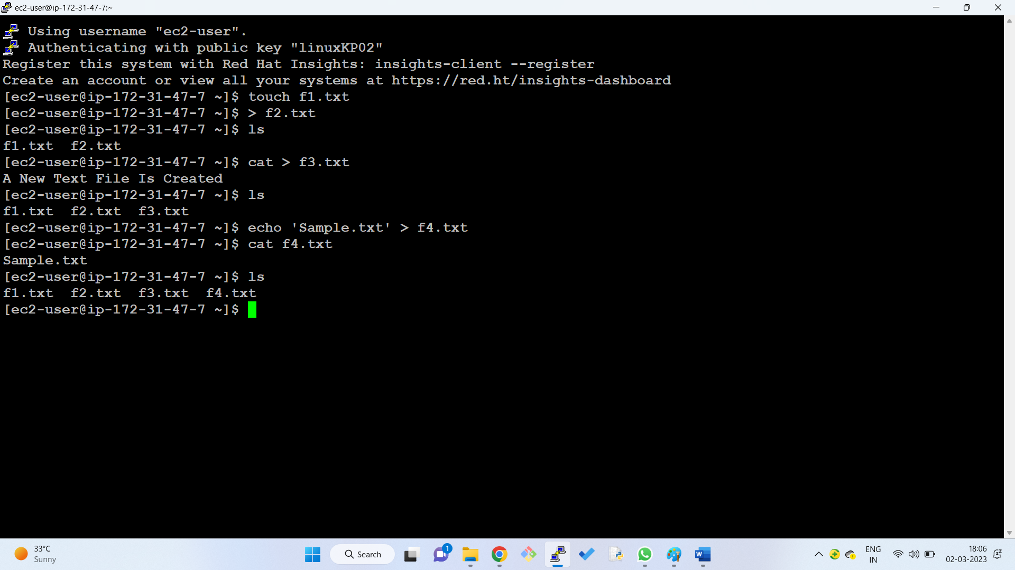

**Various way to create a file:**

1. With touch command
2. With redirect operator
3. With cat command
4. With echo command
5. Use text editor(vi, vim, nano)

**Remove a file**

1. rm f1.txt (removes a single file)
2. rm f2.txt f3.txt (removes multiple files)
3. rm -f f4.txt (force the removal of file that’s write protected)

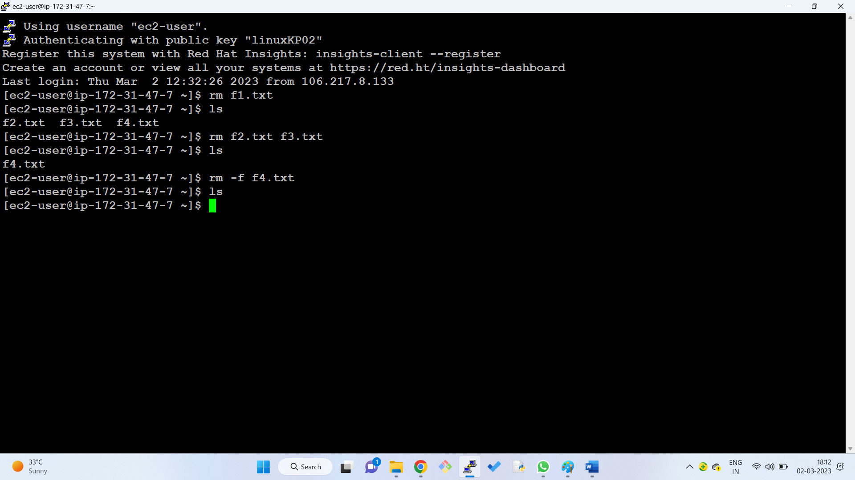

**Create a directory**

1. $mkdir dir1
2. $mkdir {test1,test2,test3}
3. $mkdir -p dir1/dirtest1/dirtest2(to make parent directories)

$ls -R (Shows recursive directory tree)

1. $mkdir -m 777 dirM (set permissions when making a directory)

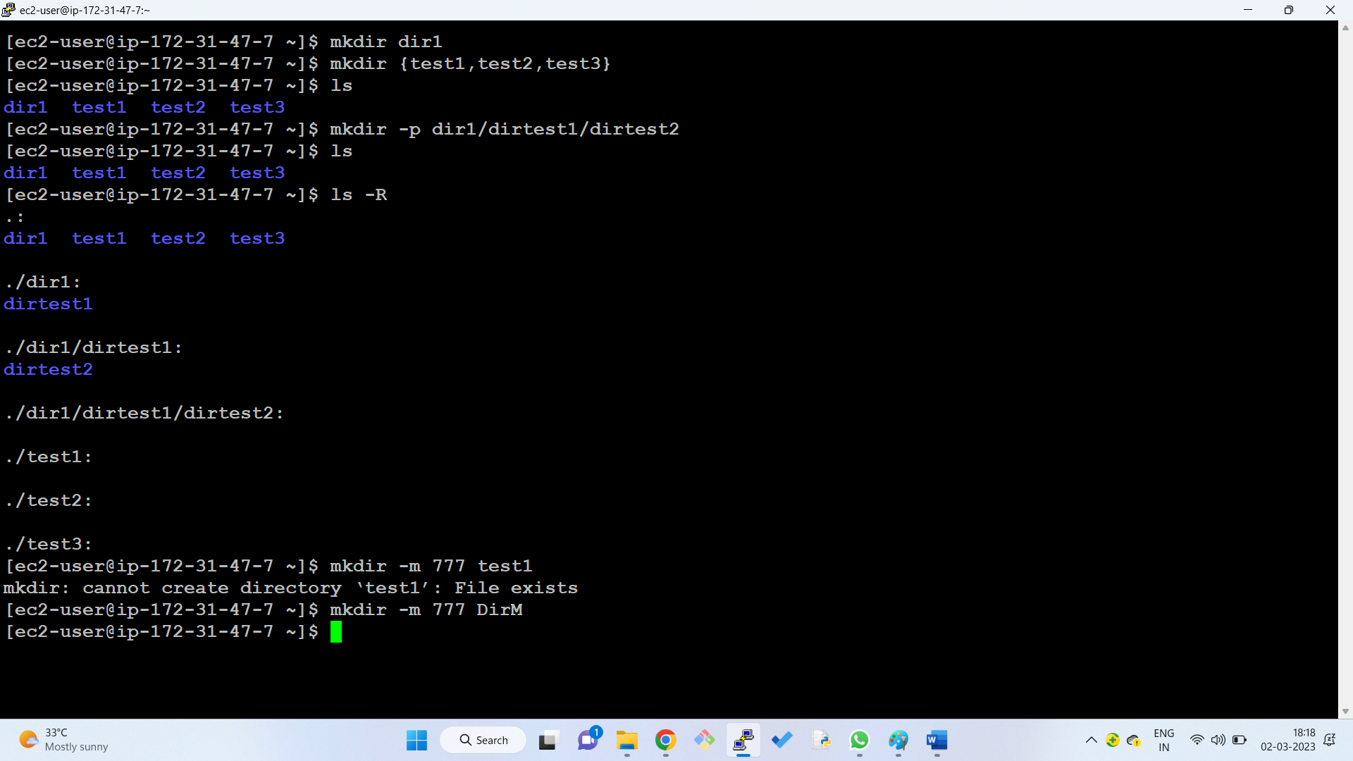

**Go to the previous directories**

1. $cd (go to home directory)
2. $cd .. (go to the previous dir)
3. $cd ~ (goes to home dir)

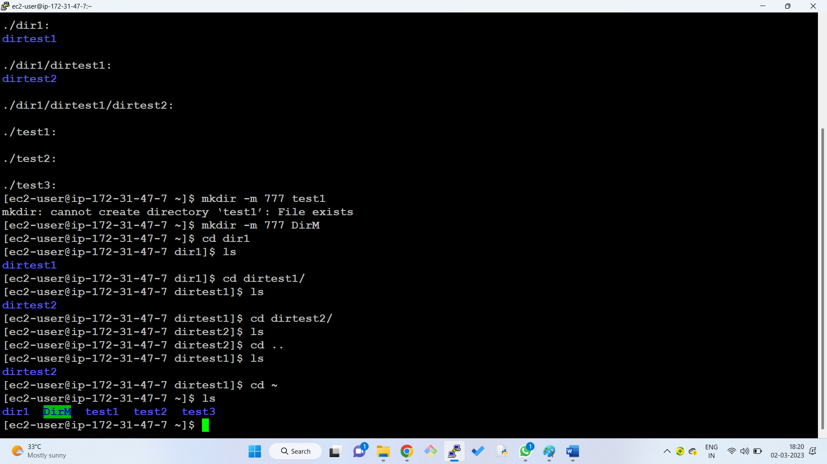

**To delete a directory**

1. $rm -r dir1 (removes directory and everything inside of it)
2. $rm -rf dir1(removes a directory without confirmation)
3. $rm -r dir1 dir2 dir3
4. $rmdir dir1 (removes empty directory)

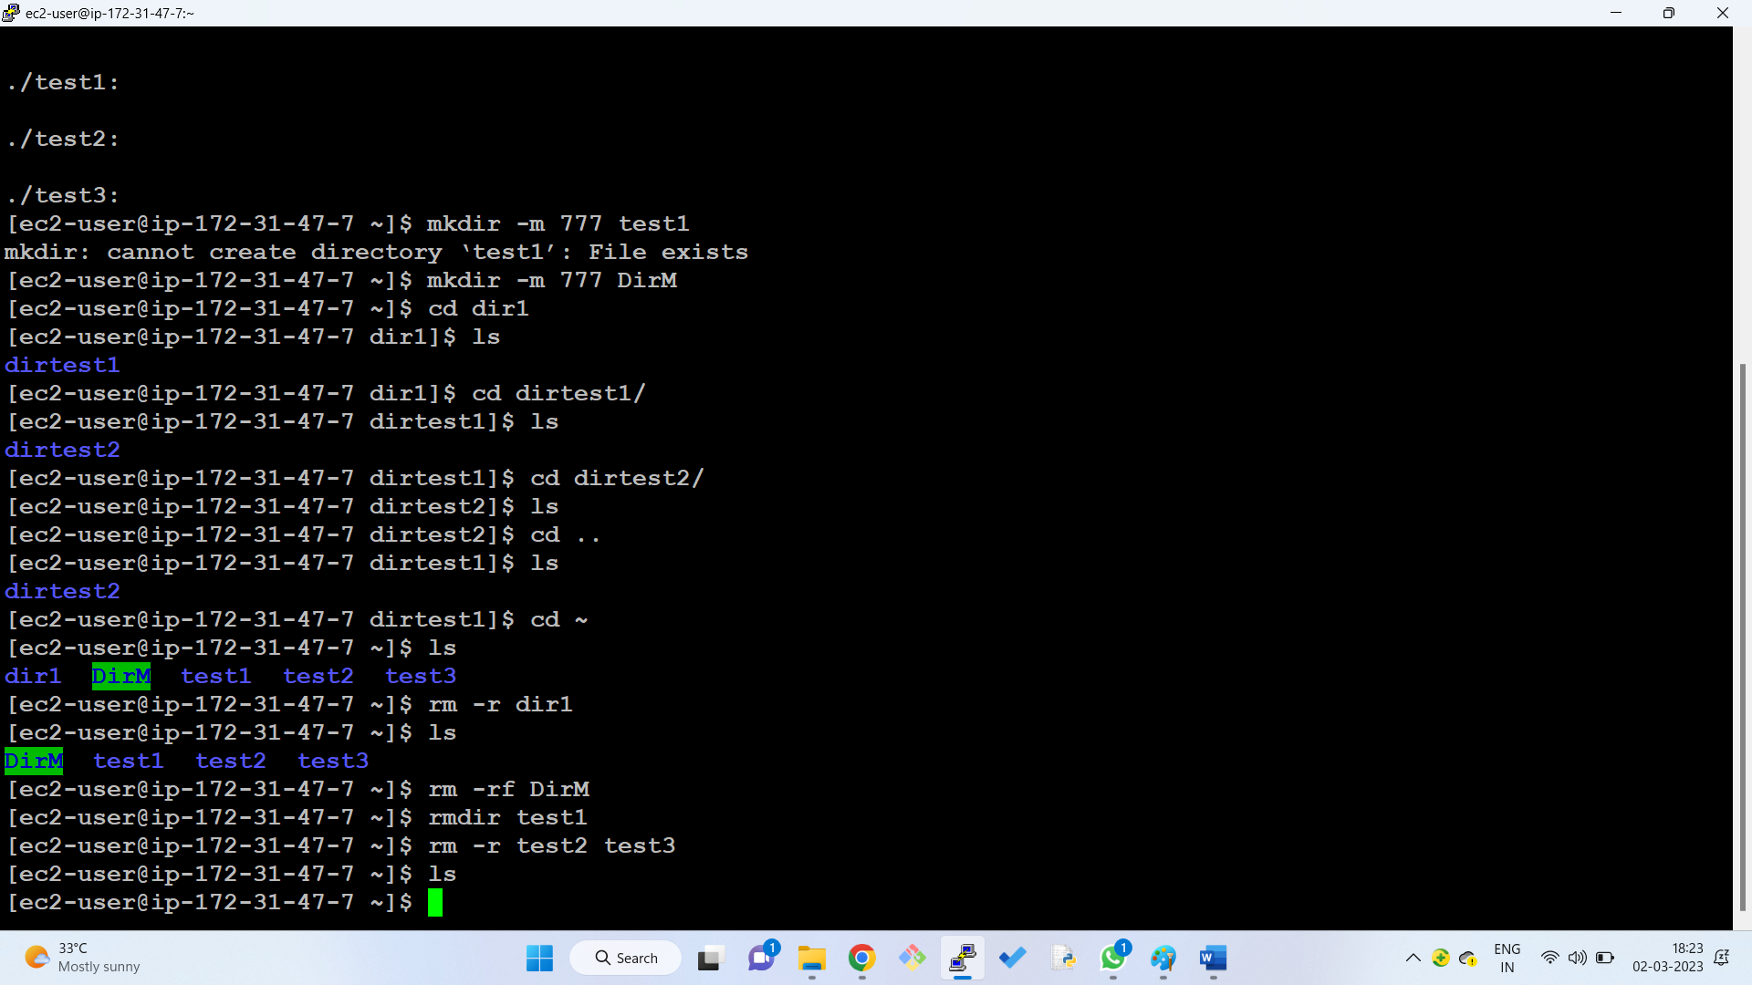

**Long list**

1. List files and directories: $ls
2. Long listing of files in linux: $ls -l
3. View hidden files in linux: $ls -a
4. List files in reverse order: $ls -r
5. Recursively list sub-directories in linux: $ls -R
6. List files and directories in reverse order: $ls -ltr
7. List files by file size in linux: $ls -ls
8. Display inode number of file or directory: $ls -i
9. List UID and GID of files: $ls -n
10. $ls --help
11. $ls --version

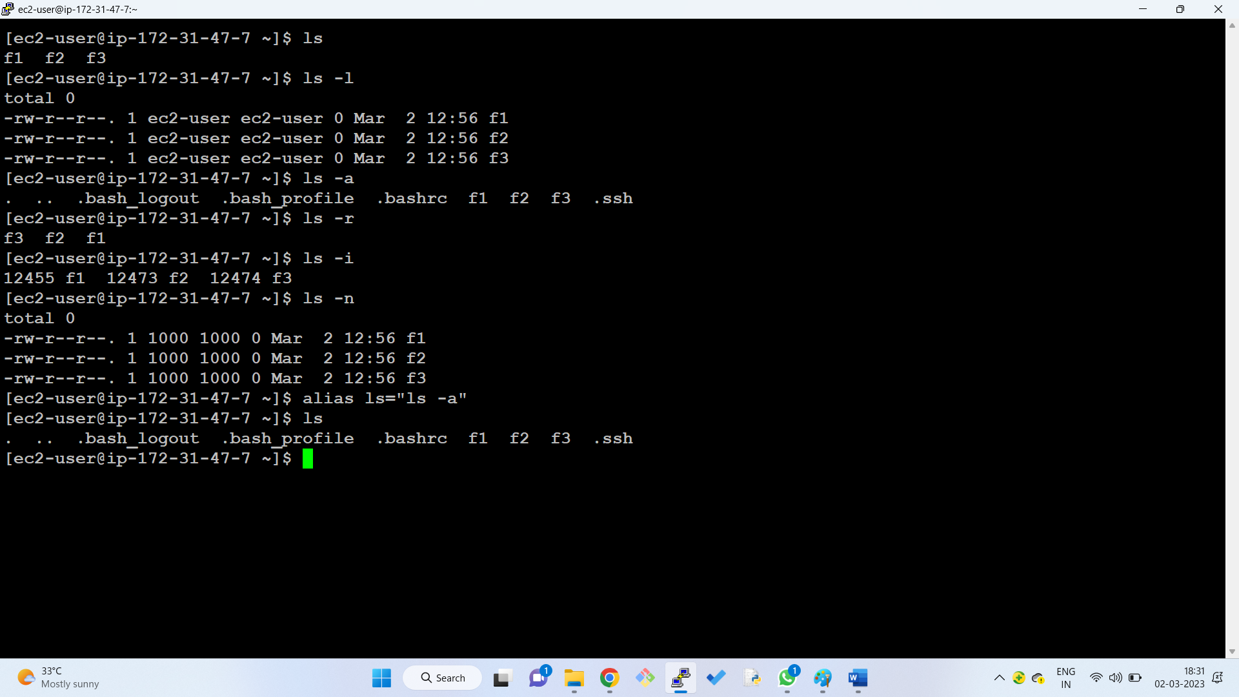

**Copy files and directories in linux**

1. $cp f1.txt f2.txt
2. $cp f1.txt dir1 (copy file to another directory)
3. $cp f1.txt dir1/f2.txt (rename and copy a file to different path)
4. $cp f1.txt f2.txt f3.txt dir1 (creates copy of all three files in dir1)
5. $cp -R documents dir1 (copies an entire folder and its subfolders and files)

**Copy using rysnc command**

rysnc – synchronize or transfer data between two locations

$rsync -a f1.txt /dir1/f1_backup.txt] ---🡪 replace f1.txt in working directory, replace /dir1/ with the destination, f1_backup.txt as the target indicates file will be renamed during copy.

$ls /dir1 (lists contents of a directory)

$cd /dir (change directory)

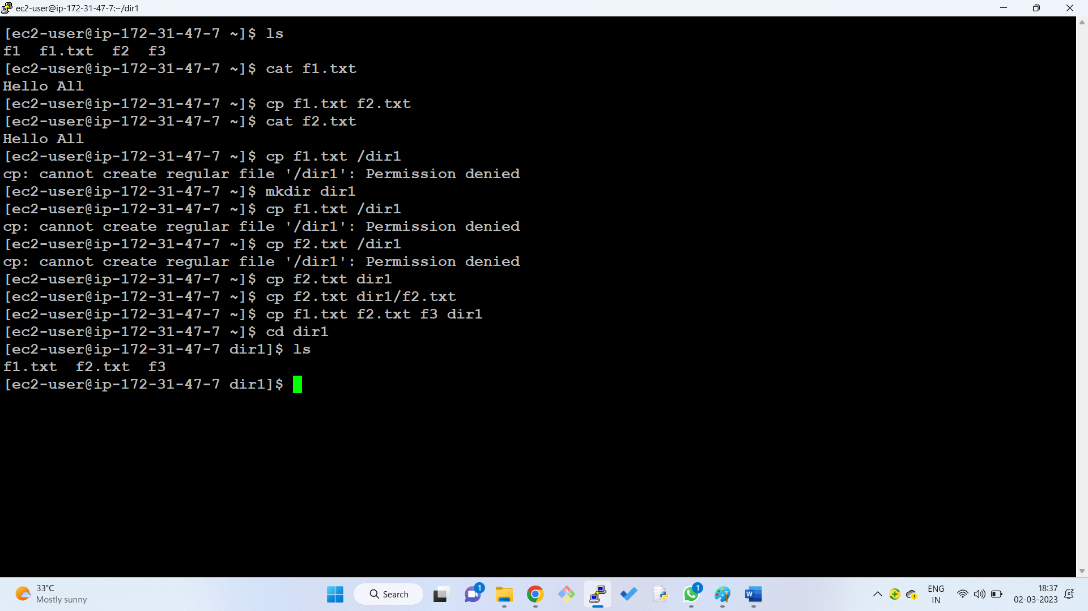

**Vi editor: basic editor in linux**

Default mode is command mode.

To type contents go to insert mode i

1. Esc:x to come out of insert mode
2. Esc:wq save and quit
3. Esc:q! exit without saving
4. Esc dd delete a line
5. Esc yy copy the line
6. Esc p paste below

**Package management in linux**

* Tree is the name of a command which can be installed in tree package.
* We have to install the package from repository.
* Name of the repository in ubuntu is apt and in redhat is yum.
* Linux community maintaining the repositories inside that there will be thousands of packages.
* An apt repository is a collection of packages.
* APT repository allows you to perform package install, removal, upgrade operations on individual packages.

**To install packages:**

Step-1: update apt repository

$sudo apt-get update

Step-2: install the package

$apt-get install packagename

**How to create a linux server in AWS Cloud?**

1. Sign up for an AWS account at <https://aws.amazon.com/>
2. Navigate to the EC2 (Elastic Compute Cloud) service within the AWS Management Console.
3. Click on “Launch Instance” to begin creating a new instance.
4. Select the Amazon Machine Image (AMI) for the Linux distribution you want to use (e.g. Amazon Linux2, Ubuntu, CentOS).
5. Choose an instance type based on the requirements of your workload.
6. Create a new keypair and attach it.
7. If you wish edit network settings.
8. Choose number of instances to create.
9. Launch instance 🡪 running state 🡪 connect to terminal

